

*DSA LAB*

**ARTIFICIAL INTELLIGENCE -> GROUP A**

Hilal Ahmad khan

**LAB INSTRUCTOR: SHAYAN SHAH**

**. It demonstrates my understanding of** DSAfunction solutions **through practical application.”**

12 Oct, 2025

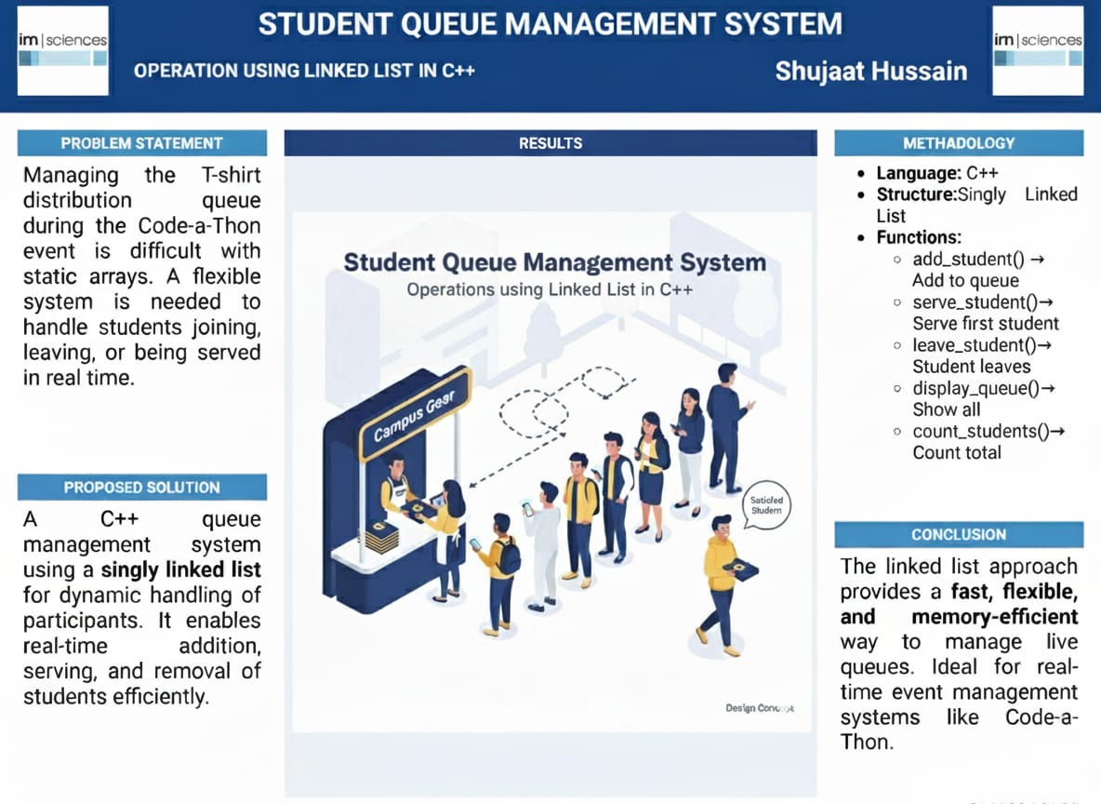

This lab provided comprehensive practice with fundamental shell scripting concepts including variables, user input, file operations,

**Acknowledgment:**

**My sincere thanks to our instructor for their guidance and support in completing this lab work.**

**Thanks…….**